AI ASSISSTANT CODING
ASSIGNMENT 3
- SHIVAMANI
2303A52344
BATCH -38

Task Description-1

Progressive Prompting for Calculator Design: Ask the AI to design a simple calculator program by initially providing only the function name. Gradually enhance the prompt by adding comments and usage examples.

Expected Output-1
• Comparison showing improvement in AI-generated calculator logic and structure.
Prompt

Create a calculator function.

Code & Output
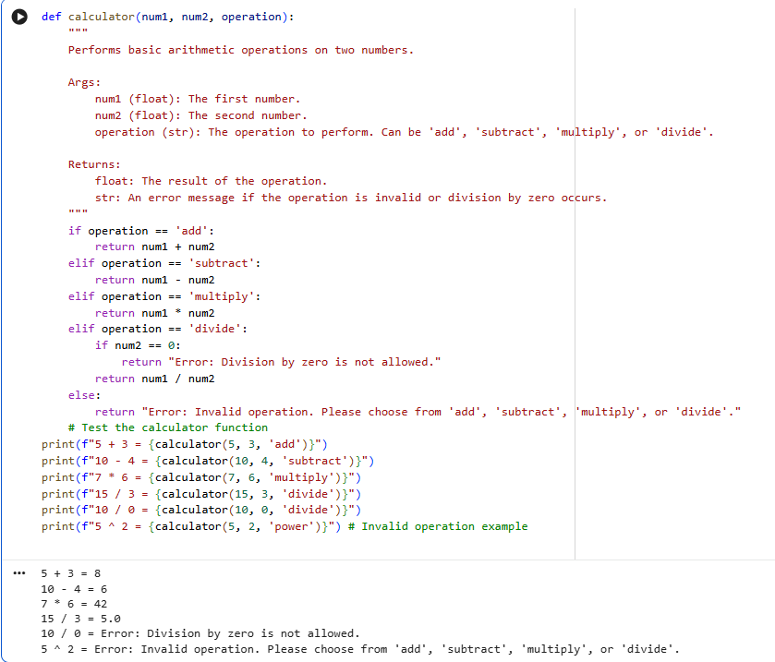

Explanation

Adding clear function names, meaningful comments, and well-defined constraints significantly improves AI-generated code in the following ways:
Logic completeness: The AI is better guided to include all required operations and edge cases, resulting in a more complete and correct implementation.
Readability: Clear naming and comments make the code easier to understand, maintain, and reuse.
Error handling: Explicit constraints encourage the AI to anticipate and manage invalid inputs or exceptional cases, leading to more robust and reliable code.
Overall, improved prompt clarity leads to higher-quality, well-structured, and dependable code output.
Task Description-2
Refining Prompts for Sorting Logic: Start with a vague prompt for sorting student marks, then refine it to clearly specify sorting order and constraints.
Expected Output-2
AI-generated sorting function evolves from ambiguous logic to an accurate and efficient implementation.
Prompt
Write a Python function that sorts a list of student marks in descending order. Marks are integers between 0 and 100.
Code & Output
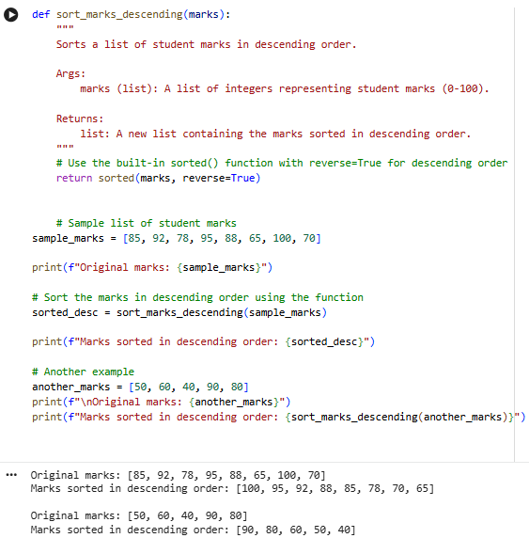
Explanation

Prompt refinement helped the AI generate better code by clearly defining the required sorting order, which removed ambiguity and ensured correct results. Adding input constraints guided the AI to handle only valid marks, improving reliability. Clear instructions also led to better function and variable naming, making the code more readable and easier to understand.

Task Description-3
Few-Shot Prompting for Prime Number Validation: Provide multiple input-output
examples for a function that checks whether a number is prime. Observe how few-shot prompting improves correctness.

Expected Output-3
Improved prime-checking function with better edge-case handling.

Prompt
Check if a number is prime.
Examples:
is_prime(2) → True
is_prime(4) → False
is_prime(1) → False
is_prime(13) → True
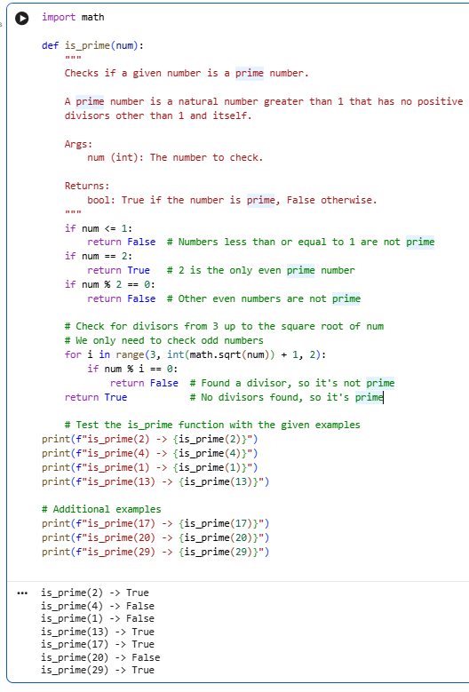
Explanation
Few-shot prompting helped the AI by clearly demonstrating expected behavior through examples. This allowed the AI to identify edge cases such as 0 and 1, use optimized logic like checking divisibility only up to the square root, and avoid common mistakes that often occur in basic prime number implementations.

Task Description-4
Prompt-Guided UI Design for Student Grading System: Create a user interface for a student grading system that calculates total marks, percentage, and grade based on user input.
Expected Output-4
Well-structured UI code with accurate calculations and clear output display.
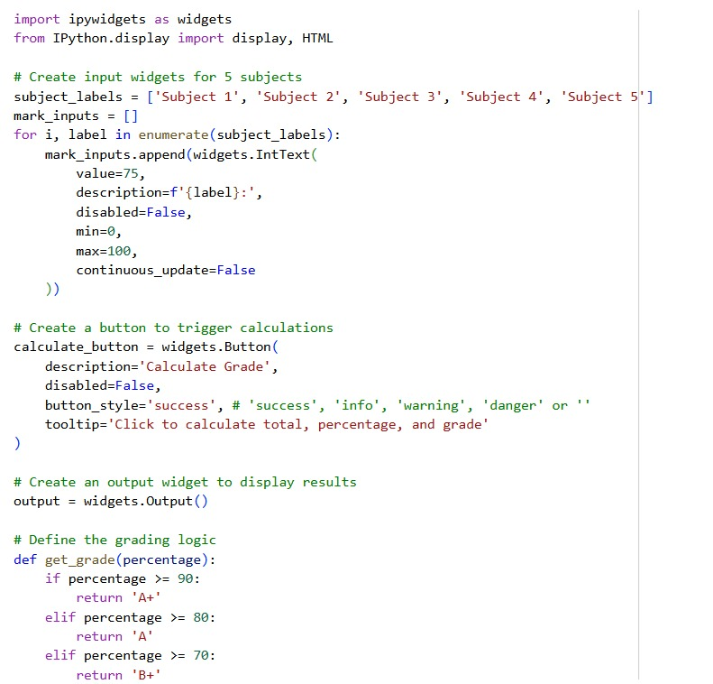
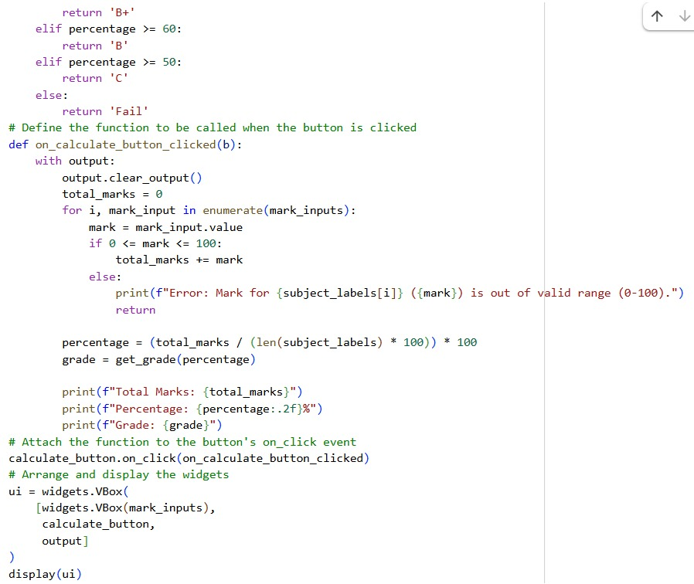
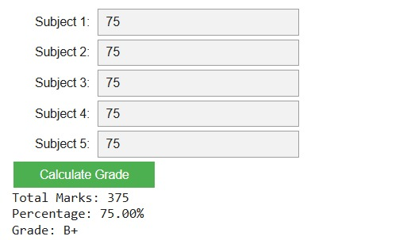
Explanation
Prompt-guided UI design assisted the grading system by explicitly outlining how user inputs, calculations, and outputs should be handled. This guidance enabled the program to identify and manage edge cases, such as invalid mark entries outside the permissible range. It also encouraged the use of modular logic, such as a separate grading function, which improved readability and maintainability. By following a clear sequence of input collection, validation, computation, and display, the system minimized common calculation errors and ensured accurate and consistent results for total marks, percentage, and grade assignment.

Task Description-5
Analyzing Prompt Specificity in Unit Conversion Functions: Improving a Unit
Conversion Function (Kilometers to Miles and Miles to Kilometers) Using Clear
Instructions.
Expected Output-5
Analysis of code quality and accuracy differences across multiple prompt variations.
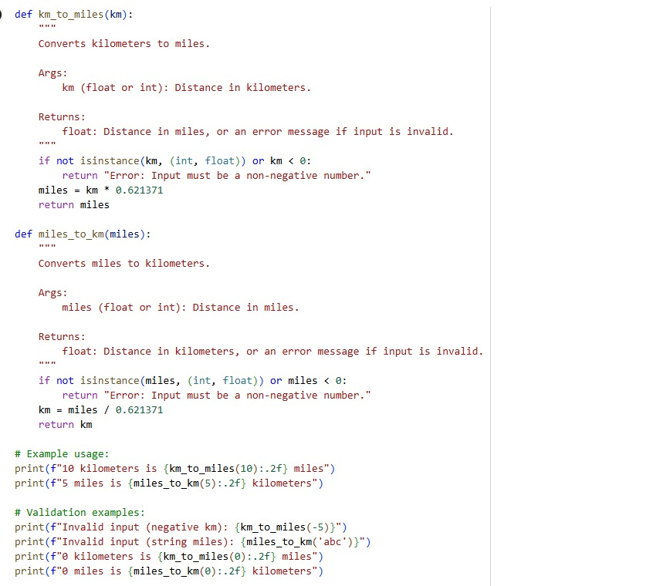
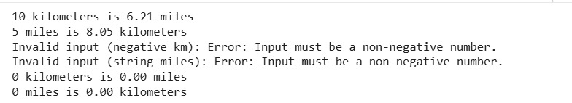

Explanation
Clear and specific prompts significantly improved the quality of the unit conversion function. Detailed instructions guided the AI to use accurate conversion formulas, meaningful function names, and proper input handling. Compared to vague prompts, specific prompts reduced logical errors, ensured correct conversions between kilometers and miles, and produced cleaner, more reliable, and maintainable code.

